**How to Integrate NAS or Windows File Server into the e-Dokyumento**

1. The default drive for all documents is located at “/drive” of the e-Dokyumento server.
2. This path can be replaced or mounted with an SMB-shared Network Attached Storage (NAS) or Windows File Server drive.
3. Below are the folders and files that must be present in the shared drive before mounting:

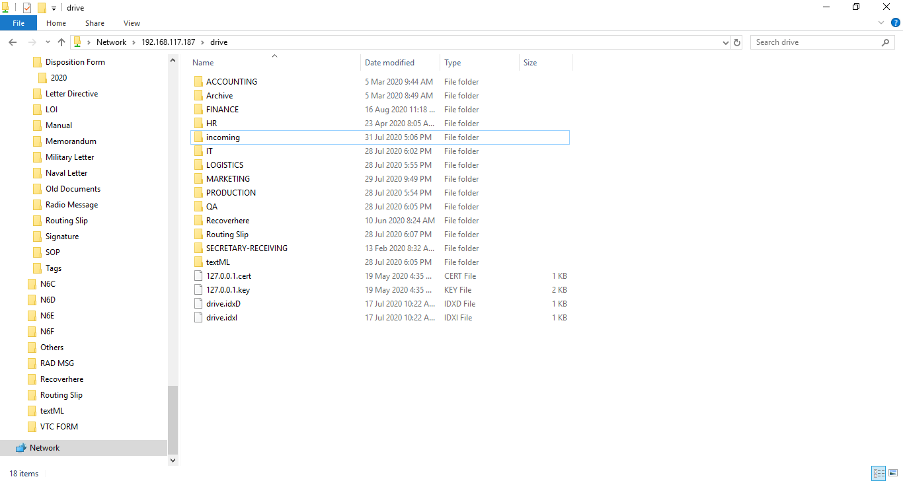

-The encircled files and folders are necessary in the shared drive when mounted to e-Dokyumento.

-All other folders can be manually created and should correspond to the Branches/Departments configured in the e-Dokyumento Web App.

-Files and folders in Linux are case sensitive.

Note: download the ‘127.0.0.1.cert’ and ‘127.0.0.1.key’ files from the original ‘drive’ folder.

On the next release, these certificate files are no longer needed in the shared drive.

1. To begin mounting, check to make sure that the shared NAS/File Server drive is accessible in the windows explorer.
2. Open Linux CLI console of the e-Dokyumento server by simultaneously pressing “ctrl + alt + f1” or “ctrl + alt + f3”.
3. Type in: ‘root’ for username and ‘p@ssword123’ for password
4. On the terminal, invoke the command “**mount -t cifs -o username=<win_share_user> password=<win_share_password> //WIN_SHARE_IP/<share_name> /drive**”

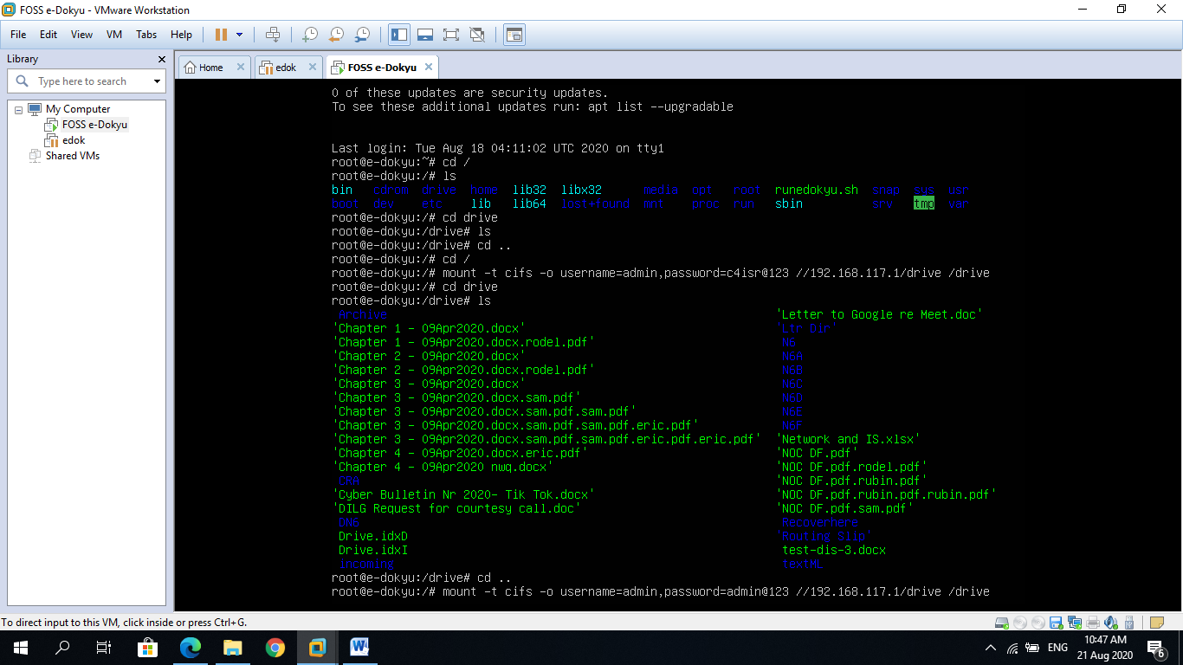

Note: If error pertaining to ‘CIFS’ occurs, install the cifs utils using the command “apt-get install cifs-utils”

1. To permanently mount the shared drive every time the server restarts, add this line to the ‘/etc/fstab’ file: “ **//<IPaddress>/<ShareName> /<mountPoint> cifs user=<userName>,pass=<passwd> 0 0** “

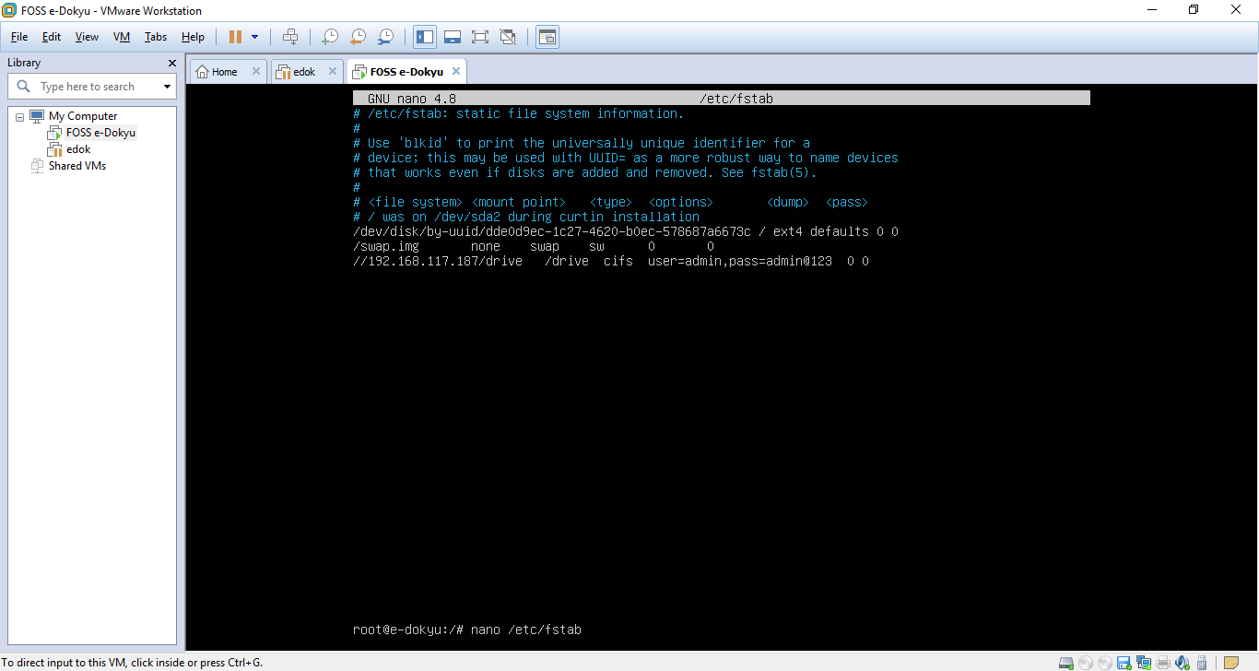

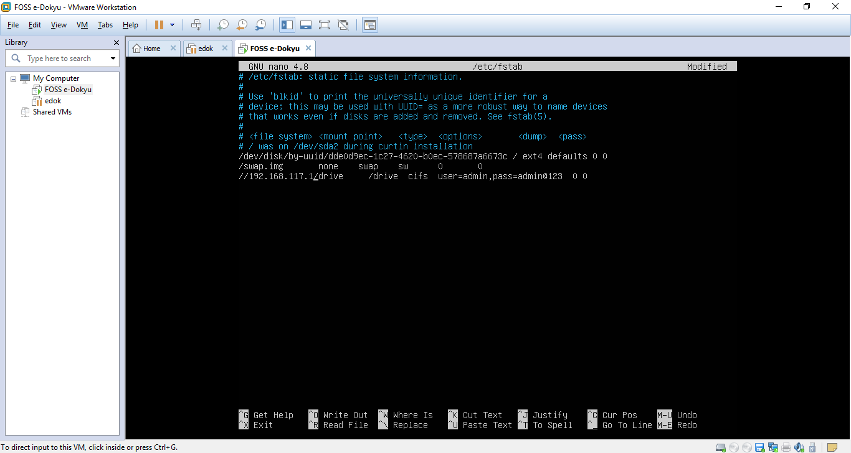

1. Reboot the server and You are done!